|  |  |
| --- | --- |
| Assignment Date | 25 September 2022 |
| Student Name | Raja Narayanan.P |
| Student Roll Number | 960519205012 |
| Maximum Marks | 2 Marks |

# Challenge:-

Upload the dataset to Cognos Analytics, prepare the data, explore and Create Interactive Dashboard.

# Solution:

Task 1: Sales by Customer:

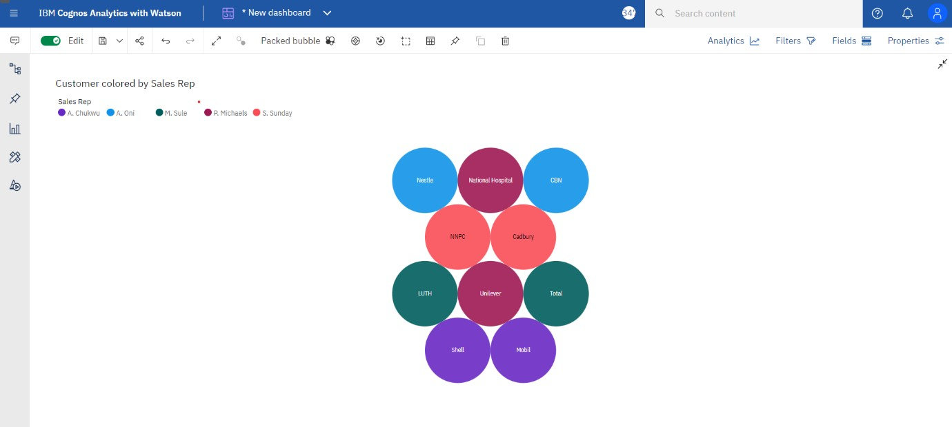

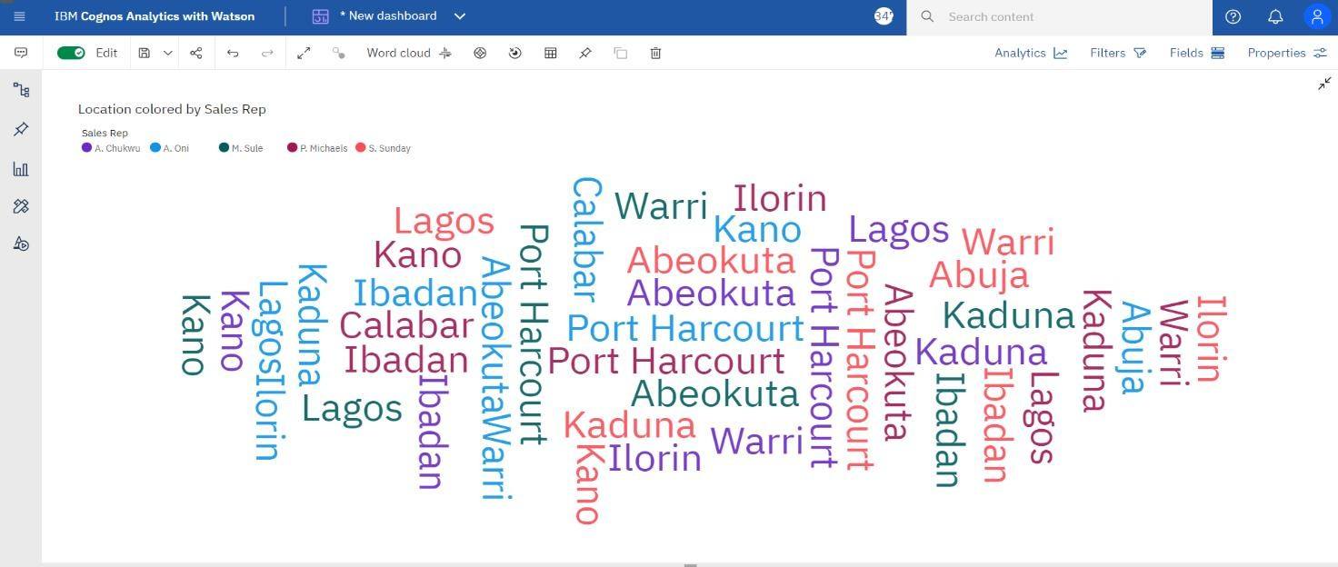

Task 3: Sales by Sales Representative:

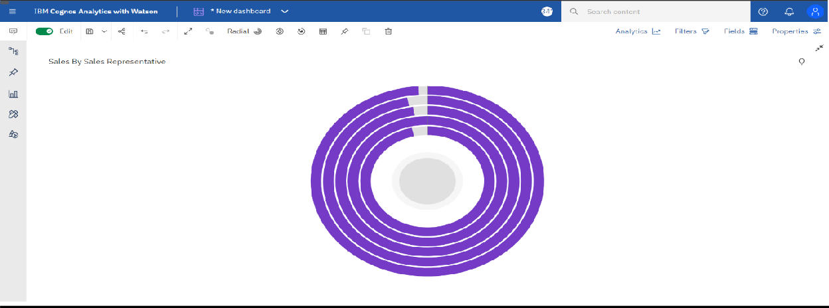

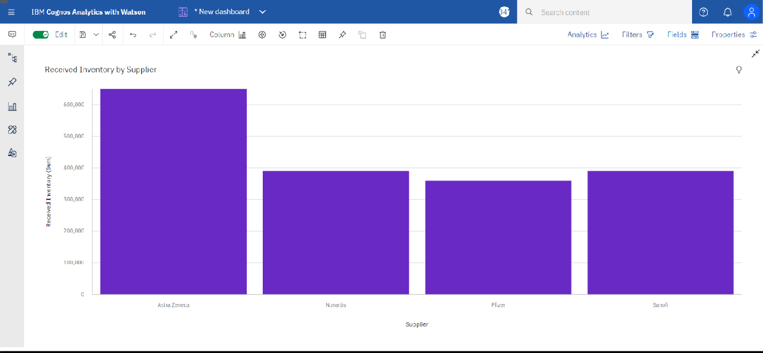

Task 5: Inventory Stock for Warehouse Locations:

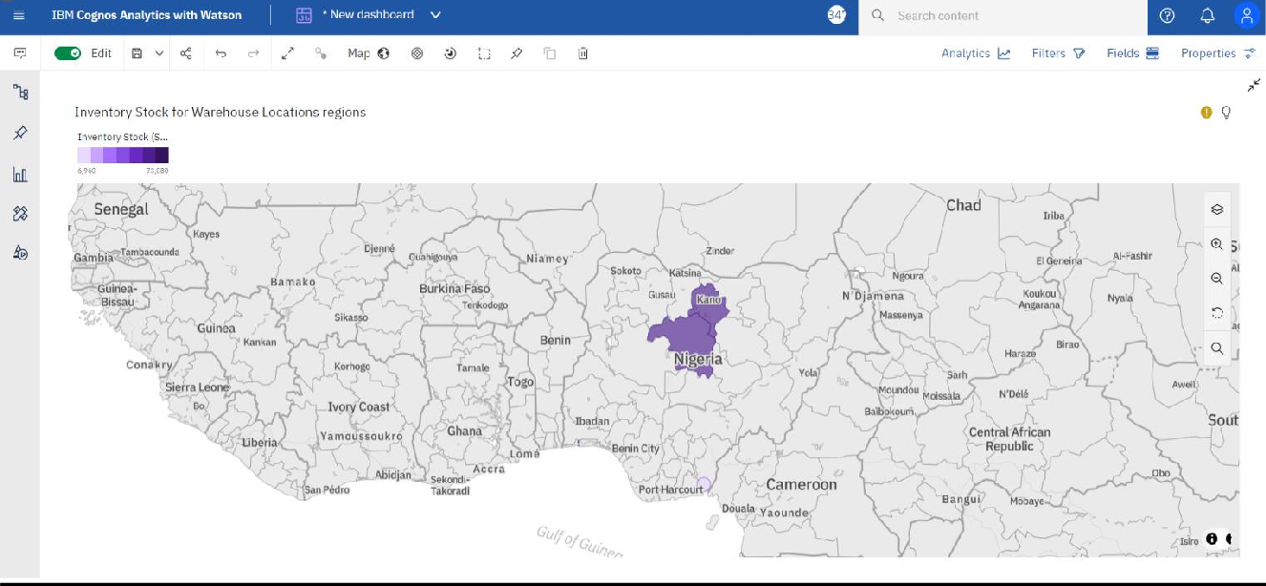

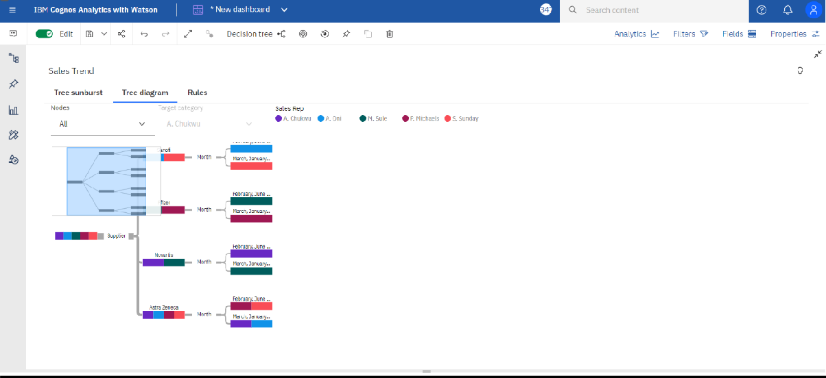

Task 7: Monthly Sales:

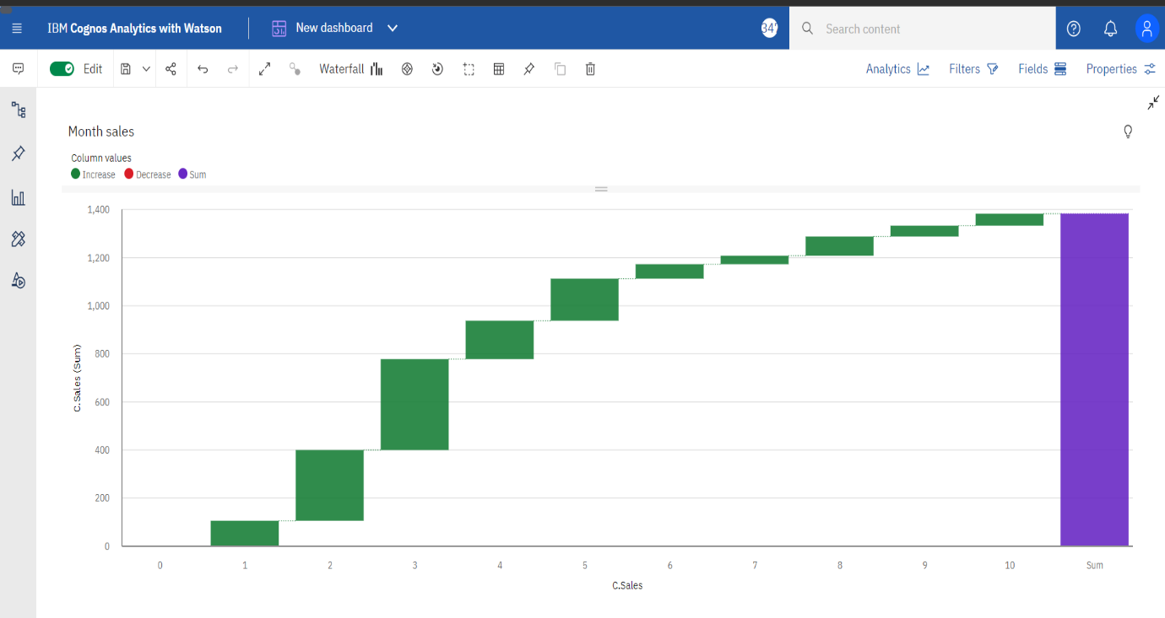

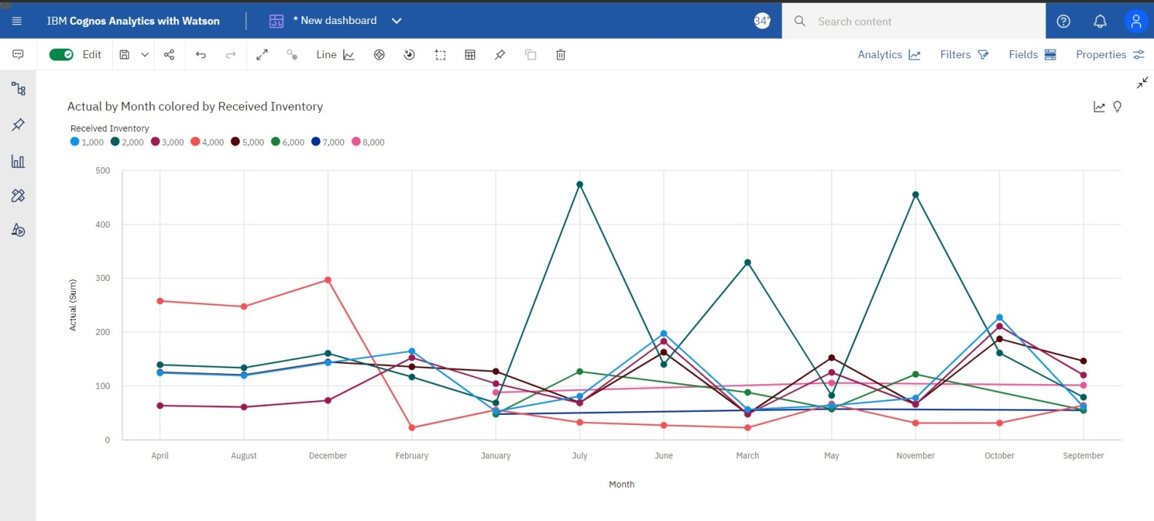

Reference:

## https://us3.ca.analytics.ibm.com/bi/?perspective=dashboard&pathRef

=.my_folders%2FAssignment- 2%2FNew%2Bdashboard&action=view&mode=dashboard&su bView=model0000018378038eec_00000000